CC Task 1
Domain | Counting and Cardinality
Cluster | Know number names and the count sequence.
Standard(s) | K.CC.1 Count to 100 by ones and tens.  K.CC.2 Count forward beginning from a given number within the known sequence (instead of beginning at 1).
Materials | none
Task | 1. Say: Start at 1 and count as far as you can (stop student after 100).  2. Say: Count by 10’s as far as you can (stop student after 100).  3. Say: Begin counting with the number 6. I’ll tell you when to stop. (Stop student at 10.)  Repeat:  - Begin at 16. Stop student at 21.  - Begin at 43. Stop student at 49.  - Begin at 62. Stop student at 72.

Continuum of Understanding
Developing Understanding | - Omits or repeats numbers in the counting sequence.  - Counts by ones, but not to 100.  - Incorrectly counts by tens to 100.  - Incorrectly begins counting from one or more given numbers.  - Inconsistently counts over the decade(s). | - Omits or repeats numbers in the counting sequence.  Rote counts by ones, without error, to_______.  Rote counts by tens, without error, to ______.  Begins counting from:  ____ 6 ____ 16 ____ 43 ____ 62
Complete Understanding | - Counts to 100 by ones.  - Counts to 100 by tens.  - Counts from all given numbers.  - Counts correctly, crossing over the decades.

Standards for Mathematical Practice
1. Makes sense and perseveres in solving problems.
2. Reasons abstractly and quantitatively.
3. Constructs viable arguments and critiques the reasoning of others.
4. Models with mathematics.
5. Uses appropriate tools strategically.
6. Attends to precision.
7. Looks for and makes use of structure.
8. Looks for and expresses regularity in repeated reasoning.

CC Task 2a
Domain | Counting and Cardinality
Cluster | Count to tell the number of objects.
Standard(s) | K.CC.4 Understand the relationship between numbers and quantities; connect counting to cardinality.  - When counting objects, say the number names in the standard order, pairing each object with one and only one number name and each number name with one and only one object.  - Understand that the last number said tells the number of objects counted. The number of objects is the same regardless of their arrangement or the order in which they were counted.  K.CC.5 Count to answer “how many?” questions about as many as 20 things.
Materials | 9 objects (e.g., cubes, bears)
Task | 1. Show the student a collection of 9 objects arranged in a line.  Say: How many do you think there are?  Now count to see how many there are. How many are there?  2. Use the same collection of 9 objects and scatter them on the table in front of the student. Say: How many do you think there are?  Count to see how many. How many are there?

Continuum of Understanding
Developing Understanding | • Skips number names in the counting sequence.  • Inconsistently pairs each object with one and only one number name.  • Inconsistently keeps track of objects counted (counting one object more than once or skipping objects).  • Incorrectly identifies the last number stated as the total amount counted.  • Incorrectly counts objects in a line and/or in a scattered arrangement. | Counts to _____ correctly.  Demonstrates one-to-one correspondence/ tagging to ______.  Keeps track of objects up to ________.
Complete Understanding | • Says the number names in the standard order.  • Pairs each object with one and only one number name.  • Keeps track of objects counted.  • Identifies the last number stated as the total amount counted.  • Correctly counts objects in a line and in a scattered arrangement.

Standards for Mathematical Practice
1. Makes sense and perseveres in solving problems.
2. Reasons abstractly and quantitatively.
3. Constructs viable arguments and critiques the reasoning of others.
4. Models with mathematics.
5. Uses appropriate tools strategically.
6. Attends to precision.
7. Looks for and makes use of structure.
8. Looks for and expresses regularity in repeated reasoning.

CC Task 2b
Domain | Counting and Cardinality
Cluster | Count to tell the number of objects.
Standard(s) | K.CC.4 Understand the relationship between numbers and quantities; connect counting to cardinality.  - When counting objects, say the number names in the standard order, pairing each object with one and only one number name and each number name with one and only one object.  - Understand that the last number said tells the number of objects counted. The number of objects is the same regardless of their arrangement or the order in which they were counted.  K.CC.5 Count to answer “how many?” questions about as many as 20 things arranged in a line, a rectangular array, or a circle, or as many as 10 things in a scattered configuration; given a number from 1-20, count out that many objects.
Materials | 18 objects (e.g., cubes, bears)
Task | 1. Show the student a collection of 9 objects arranged in a 3-by-3 array. Say:  How many do you think there are?  Now count to see how many there are. How many are there?  Repeat with 12 objects arranged in a 4-by-3 array.  Repeat with 18 objects arranged in a 6-by-3 array.  2. Show the student a collection of 9 objects arranged in a circle. Say:  How many do you think there are?  Now count to see how many there are. How many are there?  Repeat with (11, 17) objects.

Continuum of Understanding
Developing Understanding | • Skips number names in the counting sequence.  • Inconsistently pairs each object with one and only one number name.  • Inconsistently keeps track of objects counted (counting one object more than once or skipping objects).  • Incorrectly identifies the last number stated as the total amount counted.  • Incorrectly counts objects in an array and/or in arranged in a circle. | Counts to _____ correctly.  Demonstrates one-to-one correspondence/ tagging to ______.  Keeps track of objects up to ________.  When counting, moves objects when arranged in a(n)  _____ array  _____ circle
Complete Understanding | • Says the number names in the standard order.  • Pairs each object with one and only one number name.  • Keeps track of objects counted.  • Identifies the last number stated as the total amount counted.  • Correctly counts objects in an array and in a circle.

Standards for Mathematical Practice
1. Makes sense and perseveres in solving problems.
2. Reasons abstractly and quantitatively.
3. Constructs viable arguments and critiques the reasoning of others.
4. Models with mathematics.
5. Uses appropriate tools strategically.
6. Attends to precision.
7. Looks for and makes use of structure.
8. Looks for and expresses regularity in repeated reasoning.

CC Task 3a
Domain | Counting and Cardinality
Cluster | Count to tell the number of objects
Standard(s) | K.CC.4 Understand the relationship between numbers and quantities; connect counting to cardinality.  K.CC.5 Count to answer “how many?” questions about as many as 20 things arranged in a line, a rectangular array, or a circle, or as many as 10 things in a scattered configuration
Materials | BLM (Dot Cards)
Task | Place the dot cards in order, as numbered at the bottom of each card.  Say: I’m going to show you a dot card. Tell me how many you see. See if you know how many quickly without counting.

Continuum of Understanding
Developing Understanding | - Counts the dots to determine how many.  - Estimates the dots to determine how many.  - Incorrectly identifies the amount on one or more cards.  - Identifies the correct amount, but does not instantly recognize the amount. | Strategies Used:  - Counts All/On  - Estimates  - Knows instantaneously without counting  Subitizes dots arranged in a:  - line  - array  - circle  - scattered  Subitizes:  - 3  - 4  - 5  - 6
Complete Understanding | - Identifies the amount on each card quickly, without counting.  - Subitizes the amount on each card, regardless of the arrangement of dots.

Standards for Mathematical Practice
1. Makes sense and perseveres in solving problems.
2. Reasons abstractly and quantitatively.
3. Constructs viable arguments and critiques the reasoning of others.
4. Models with mathematics.
5. Uses appropriate tools strategically.
6. Attends to precision.
7. Looks for and makes use of structure.
8. Looks for and expresses regularity in repeated reasoning.

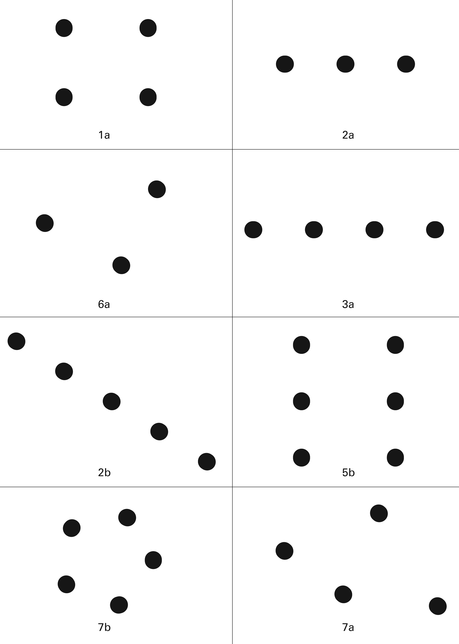

CC Task 3b
Domain | Counting and Cardinality
Cluster | Count to tell the number of objects
Standard(s) | K.CC.4 Understand the relationship between numbers and quantities; connect counting to cardinality.
Materials | BLM (Dot Cards)
Task | Place the dot cards in order, as numbered at the bottom of each card. Say: I’m going to show you a dot card. Tell me how many you see. See if you know how many quickly without counting.  Show Card 1, and then ask: “What if I added one more dot? How many dots would there be? What if I added one more dot? What if I added one more dot?”  Repeat with remaining dot cards.

Continuum of Understanding
Developing Understanding | • Counts the dots to determine how many.  • Estimates the dots to determine how many.  • Incorrectly identifies the amount on one or  more cards.  • Identifies the correct amount, but does not instantly recognize the amount.  • Incorrectly identifies “one-more”.  • Counts to determine the new amount. | Strategies Used:  - Counts All/On  - Estimates  - Knows instantaneously without counting  Subitizes dots arranged in a:  - line  - array  - circle  - scattered  Subitizes:  _____ 3 _____ 4 _____ 5 _____ 6  Tells one more than:  _____ 3 _____ 4 _____ 5
Complete Understanding | • Identifies the amount on each card quickly, without counting.  • Subitizes the amount on each card, regardless of the arrangement of dots.  • Knows “one-more” instantly, without counting.

Standards for Mathematical Practice
1. Makes sense and perseveres in solving problems.
2. Reasons abstractly and quantitatively.
3. Constructs viable arguments and critiques the reasoning of others.
4. Models with mathematics.
5. Uses appropriate tools strategically.
6. Attends to precision.
7. Looks for and makes use of structure.
8. Looks for and expresses regularity in repeated reasoning.

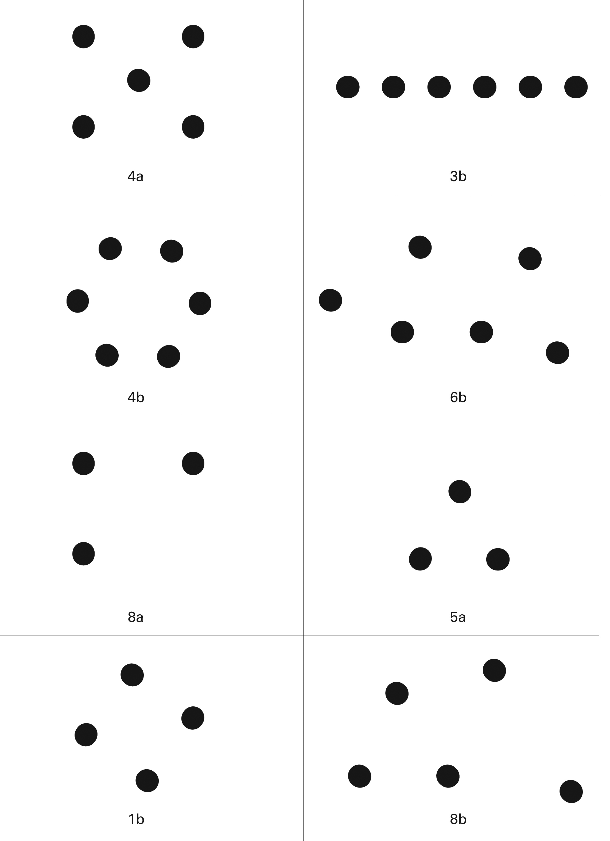

CC Task 4
Domain | Counting and Cardinality
Cluster | Count to tell the number of objects.
Standard(s) | K.CC.4 Understand the relationship between numbers and quantities; connect counting to cardinality  c.) Understand that each successive number name refers to a quantity that is one larger.
Materials | 12 cubes
Task | - Give student a set of 9 cubes to count. Say: Count to see how many you have. Add 1 more cube to the set. Ask: How many do I have now?  Add I more. Ask: How many now?  Add 1 more. Ask: How many now?  - Remove the cubes. Ask: What if we had 5 cubes and added one more? How many cubes would there be then? Repeat with numbers (10, 16, 19).

Continuum of Understanding
Developing Understanding | - Incorrectly identifies “one-more” with and/or without objects.  - Counts to determine the new amount. | Tells one more with objects:  _____ 9 to 10 _____ 10 to 11  _____ 11 to 12  Tells one more without objects:  _____ 5 to 6 _____ 10 to 11  _____ 16 to 17 _____ 19 to 20
Complete Understanding | - Correctly identifies “one-more” with objects.  - Correctly identifies “one-more” without objects.  - Knows “one-more” instantly, without counting.

Standards for Mathematical Practice
1. Makes sense and perseveres in solving problems.
2. Reasons abstractly and quantitatively.
3. Constructs viable arguments and critiques the reasoning of others.
4. Models with mathematics.
5. Uses appropriate tools strategically.
6. Attends to precision.
7. Looks for and makes use of structure.
8. Looks for and expresses regularity in repeated reasoning.

CC Task 5a
Domain | Counting and Cardinality
Cluster | Know number names and the count sequence.
Standard(s) | K.CC.3 Write numbers from 0 to 20. Represent a number of objects with a written numeral 0-20 (with 0 representing a count of no objects).  K.CC.4 Understand the relationship between numbers and quantities; connect counting to cardinality.  K.CC.5 Count to answer “how many?” questions about as many as 20 things.
Materials | Set of 20 objects (e.g., cubes, bears), pencil, paper
Task | 1. Give the student a set of 4 objects in a scattered arrangement. Say:  How many do you think there are?  Now count to see how many there are.  How many are there? Write the number on this piece of paper.  Repeat with 7, 10 objects in a scattered arrangement.  2. Show the student a set of 12 objects arranged in a line.  How many do you think there are?  Now count to see how many there are.  How many are there? Write that number on this piece of paper.  Repeat with 16, 20 objects arranged in a line.

Continuum of Understanding
Developing Understanding | • Skips number names in the counting sequence.  • Inconsistently pairs each object with one and only one number name.  • Inconsistently keeps track of objects counted.  • Incorrectly identifies the last number counted as the total amount of the set.  • Incorrectly writes a number(s) for the amount counted. | Demonstrates one-to-one correspondence/ tagging to _____ with objects.  Demonstrates one-to-one correspondence/ tagging to _____ with objects.  Keeps track of objects to _____ .  Writes numbers*:  _____ 4 _____7 _____ 10 _____12 _____ 16 _____ 20
Complete Understanding | • Says the number names in the standard order.  • Pairs each object with one and only one number name.  • Keeps track of objects counted, regardless whether in a scattered arrangement or in a line.  • Identifies the last number counted as the total amount of the set, answering the question “how many?” correctly.  • Writes the number that corresponds to the amount counted.
*NOTE: Reversal of numbers is anticipated due to varied development of fine motor and visual development. A numeral that is reversed is still correct if it resembles the numeral.

Standards for Mathematical Practice
1. Makes sense and perseveres in solving problems.
2. Reasons abstractly and quantitatively.
3. Constructs viable arguments and critiques the reasoning of others.
4. Models with mathematics.
5. Uses appropriate tools strategically.
6. Attends to precision.
7. Looks for and makes use of structure.
8. Looks for and expresses regularity in repeated reasoning.

CC Task 5b
Domain | Counting and Cardinality
Cluster | Know number names and the count sequence.
Standard(s) | K.CC.3 Write numbers from 0 to 20. Represent a number of objects with a written numeral 0-20 (with 0 representing a count of no objects).  K.CC.4 Understand the relationship between numbers and quantities; connect counting  to cardinality.  K.CC.5 Count to answer “how many?” questions about as many as 20 things arranged in a line, a rectangular array, or a circle, or as many as 10 things in a scattered configuration; given a number from 1-20, count out that many objects.
Materials | Student Forms for numbers (8) (13) (19)
Task | Show the student the student form(s). Say: Look at the number and count out (or draw or use stickers or stamps) to show the number you see.

Continuum of Understanding
Developing Understanding | • Represents one or more sets incorrectly.  • Incorrectly counts to determine amount.  • Reads the number incorrectly, but represents the correct number of objects for the incorrect number. | Draws the items in a(n):  _____ scattered arrangement  _____ line  _____ array  _____ circle  _____ Other:  Represents correctly:  _____ 8 _____ 13 _____ 19
Complete Understanding | • Represents all 3 sets correctly.

Standards for Mathematical Practice
1. Makes sense and perseveres in solving problems.
2. Reasons abstractly and quantitatively.
3. Constructs viable arguments and critiques the reasoning of others.
4. Models with mathematics.
5. Uses appropriate tools strategically.
6. Attends to precision.
7. Looks for and makes use of structure.
8. Looks for and expresses regularity in repeated reasoning.

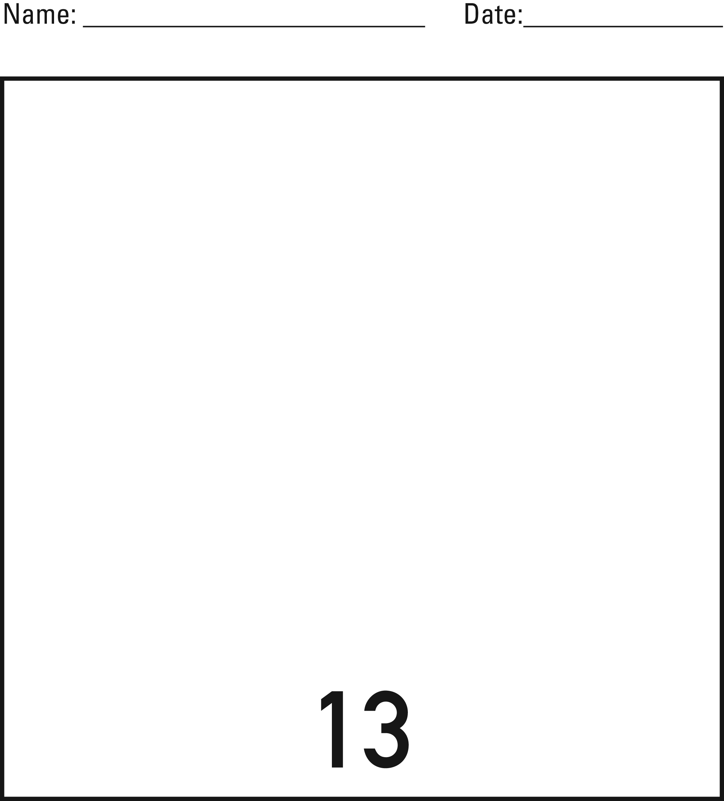

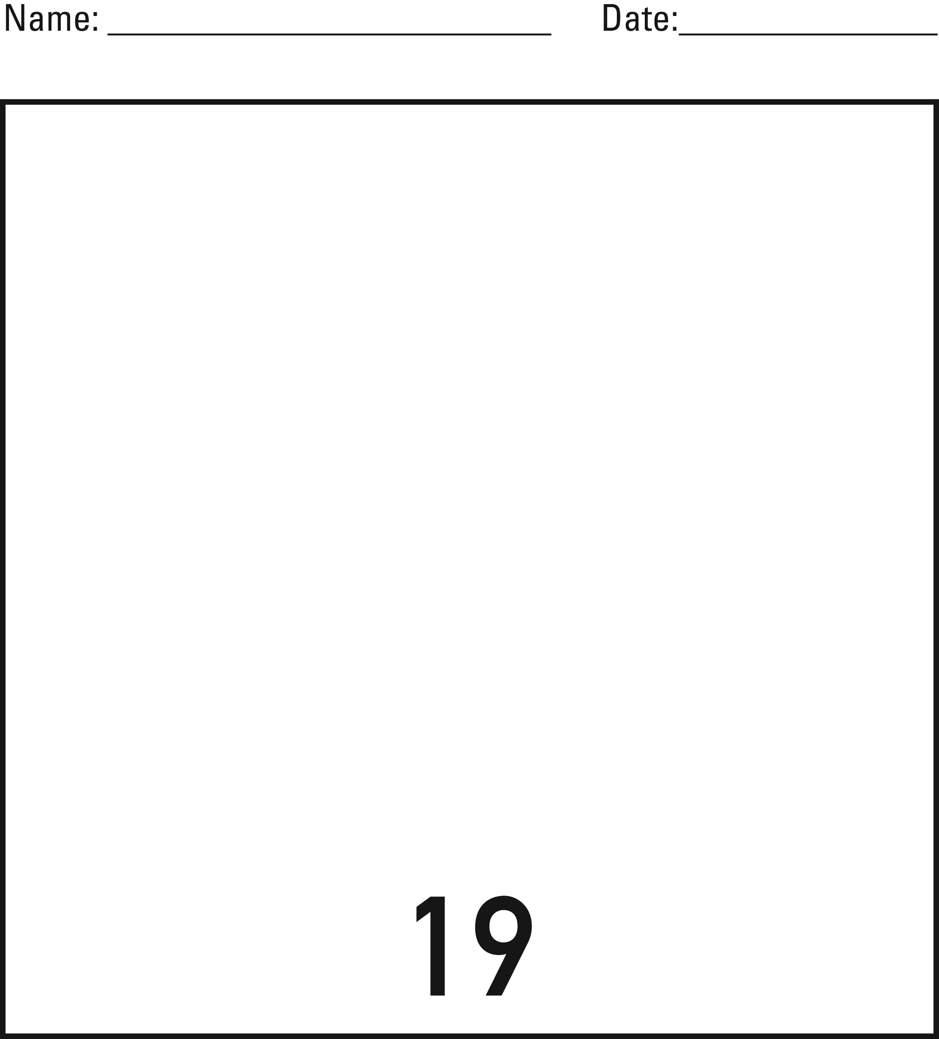

CC Task 5c
Domain | Counting and Cardinality
Cluster | Know number names and the count sequence.
Standard(s) | K.CC.3 Write numbers from 0 to 20. Represent a number of objects with a written numeral 0-20 (with 0 representing a count of no objects).  K.CC.4 Understand the relationship between numbers and quantities; connect counting to cardinality.  K.CC.5 Count to answer “how many?” questions about as many as 20 things arranged in a line, a rectangular array, or a circle, or as many as 10 things.
Materials | SF, pencil
Task | Show the student SF. Say: Count the items in each box and write the number on the line that tells how many.

Continuum of Understanding
Developing Understanding | - Counts one or more items incorrectly.  - Counts item(s) correctly, but writes an incorrect numeral.  - Counts item(s) incorrectly, but writes a numeral that represents the incorrect amount. | The student correctly counts and writes*:  The student correctly counts and writes*:  _____ 0 _____ 3  _____ 5 _____ 6  _____ 8 _____10  _____12 _____14  _____20
Complete Understanding | - Correctly counts all items.  - Writes all corresponding numerals.
*NOTE: Reversal of numbers is anticipated due to varied development of fine motor and visual development. A numeral that is reversed is still correct if it resembles the numeral.

Standards for Mathematical Practice
1. Makes sense and perseveres in solving problems.
2. Reasons abstractly and quantitatively.
3. Constructs viable arguments and critiques the reasoning of others.
4. Models with mathematics.
5. Uses appropriate tools strategically.
6. Attends to precision.
7. Looks for and makes use of structure.
8. Looks for and expresses regularity in repeated reasoning.

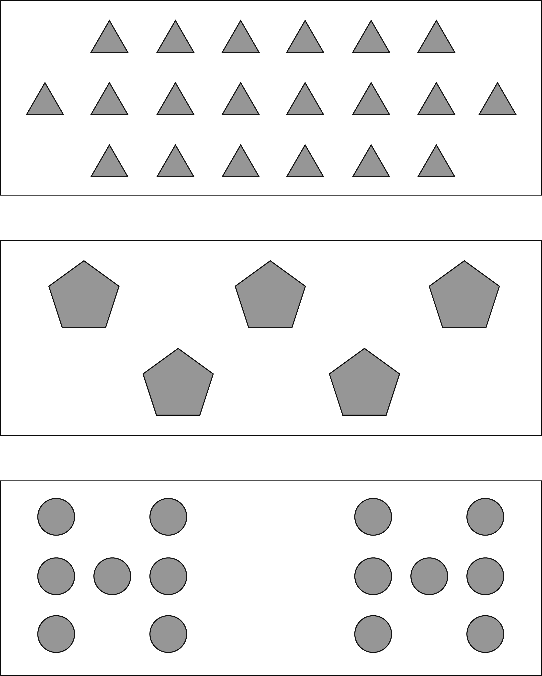

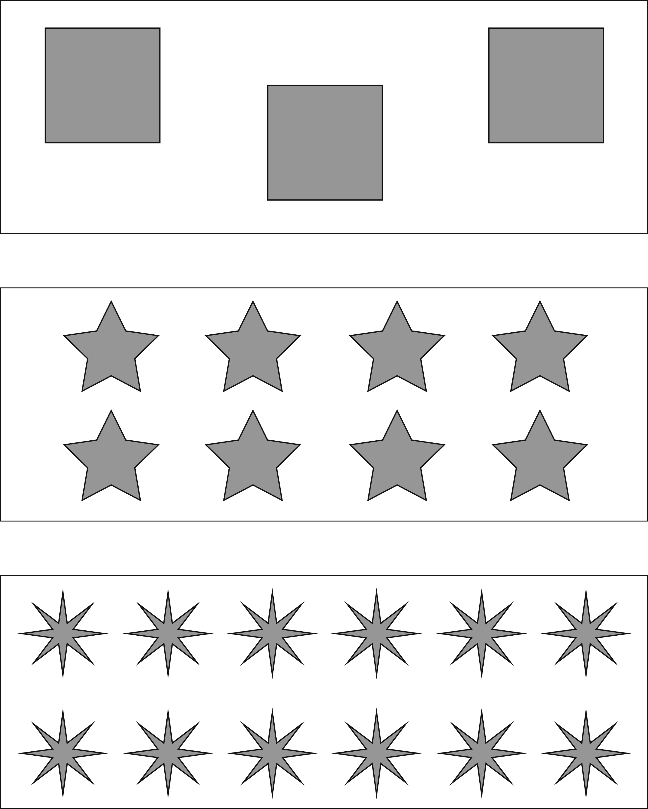
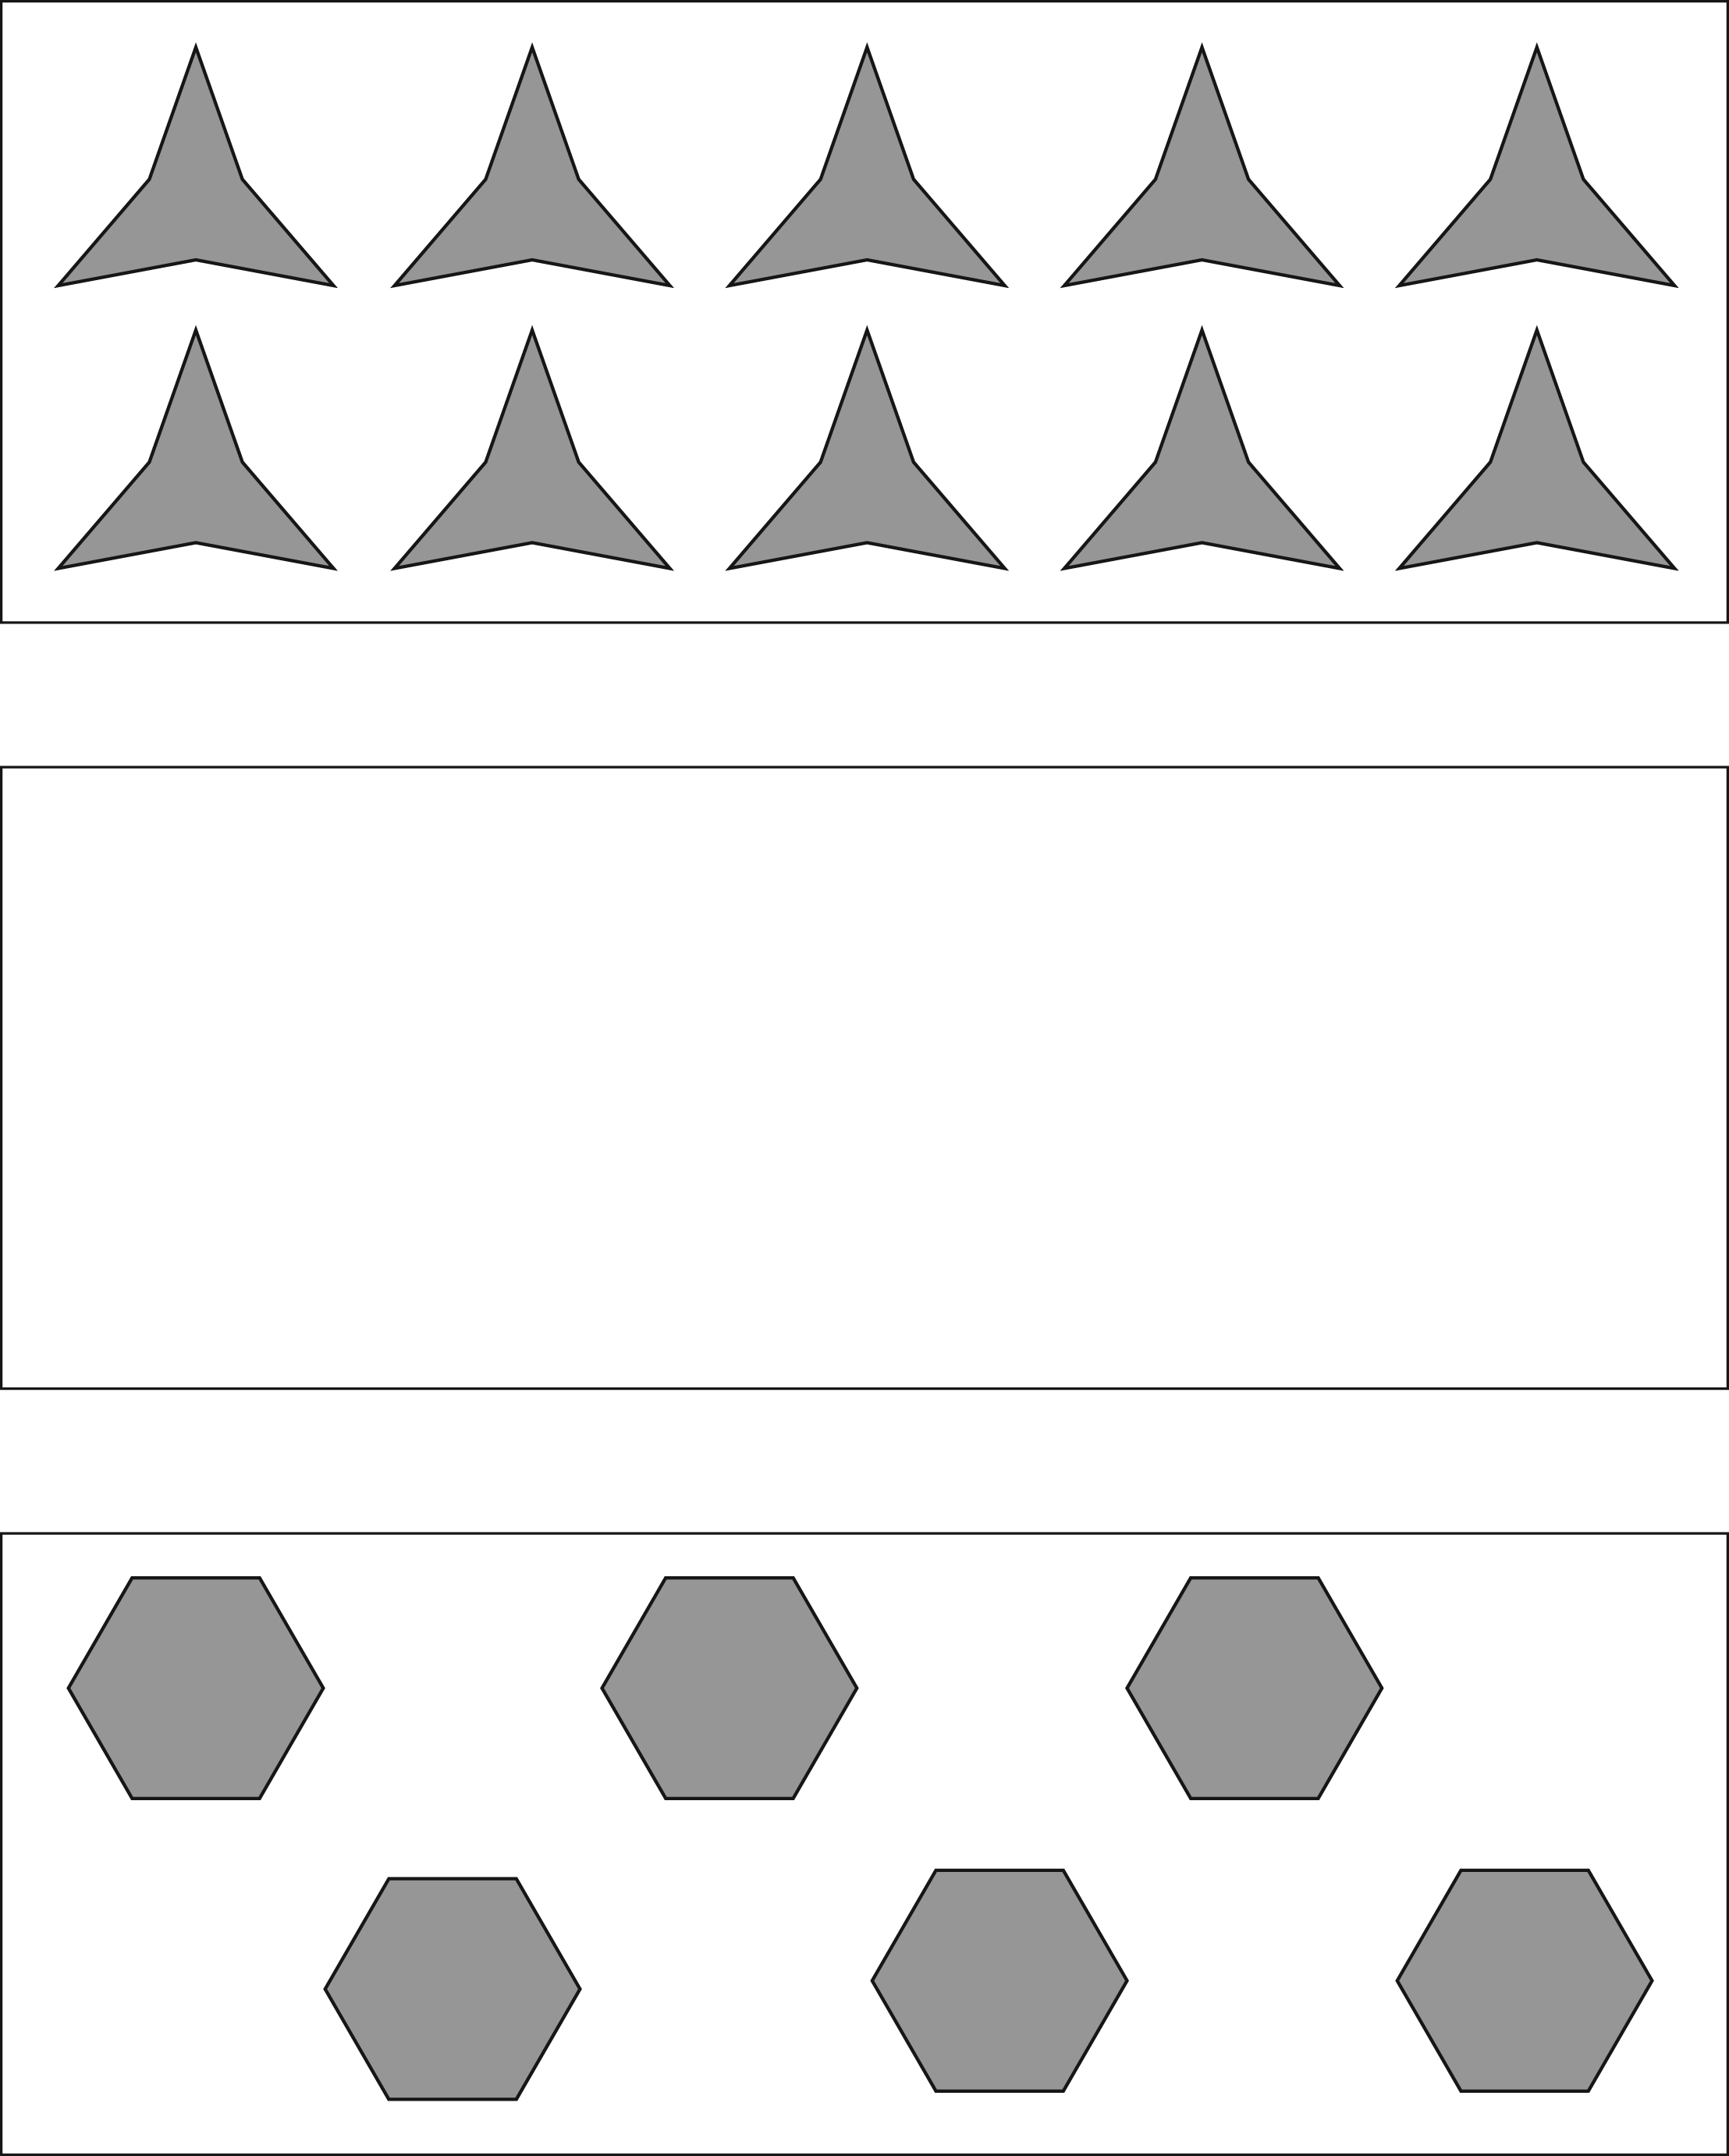

KCC Task 6a
Domain | Counting and Cardinality
Cluster | Compare numbers.
Standard(s) | K.CC.6 Identify whether the number of objects in one group is greater than, less than, or equal to the number of objects in another group, e.g., by using matching and counting strategies.
Materials | 5 yellow cubes, 4 blue cubes, 7 green cubes, 7 red cubes
Task | 1. Give the student a set of 5 yellow cubes and a set of 4 blue cubes. Say: There are some yellow cubes in this set and some blue cubes in this set. How many yellow cubes are there? How many blue cubes are there?  Which set has more or is there an equal amount of cubes in each set?  2. Give the student a set of 7 green cubes and a set of 7 red cubes. Say: There are some green cubes in this set and some red cubes in this set. How many green cubes are there? How many red cubes are there?  Which set has less or is there an equal amount of cubes in each set?

Continuum of Understanding
Developing Understanding | • Counts the amount in one or more sets incorrectly.  • States that there are more blue cubes than yellow cubes or states that there is the same number of cubes in each set.  • Identifies either the green or the red cubes as the set that has less.  • Attempts to use a counting or matching strategy to compare the sets, but incorrectly answers the question(s). | - Uses a counting strategy to determine which set has more/less.  - Uses a matching strategy to determine which set has more/less or the same.  - Uses fair shares to determine which set has more/less or the same.
Complete Understanding | • Correctly counts the amount in each set.  • Correctly identifies the set of yellow cubes as the set with the most.  • Correctly identifies that both the green and red cubes have the same amount.

Standards for Mathematical Practice
1. Makes sense and perseveres in solving problems.
2. Reasons abstractly and quantitatively.
3. Constructs viable arguments and critiques the reasoning of others.
4. Models with mathematics.
5. Uses appropriate tools strategically.
6. Attends to precision.
7. Looks for and makes use of structure.
8. Looks for and expresses regularity in repeated reasoning.

KCC Task 6b
Domain | Counting and Cardinality
Cluster | Compare numbers
Standard(s) | K.CC.6 Identify whether the number of objects in one group is greater than, less than, or equal to the number of objects in another group, e.g., by using matching and counting strategies.
Materials | 7 green cubes, 9 red cubes, 4 green cubes, 4 yellow cubes
Task | - Give the student a set of 4 green cubes and a set of 4 yellow cubes. Ask:  There are some green cubes in this set and some yellow cubes in this set. How many green cubes are there? How many yellow cubes are there?  Which set has less or is there an equal amount of cubes in each set?  - Give the student a set of 7 green cubes and a set of 9 red cubes. Say:  There are some green cubes in this set and some red cubes in this set. How many green cubes are there? How many red cubes are there?  Which set has less or is there an equal amount of cubes in each set?

Continuum of Understanding
Developing Understanding | - Counts the amount in one or more sets incorrectly.  - States that there are more blue cubes than yellow cubes or states that there is the same number of cubes in each set.  - Identifies either the green or the red cubes as the set that has less.  - Attempts to use a counting or matching strategy to compare the sets, but incorrectly answers the question(s). | - Uses a counting strategy to determine which set has more/less.  - Uses a matching strategy to determine which set has more/less or the same.  - Uses fair shares to determine which set has more/less or the same.
Complete Understanding | - Correctly counts the amount in each set.  - Correctly identifies the set of yellow cubes as the set with the most.  - Correctly identifies that both the green and red cubes have the same amount.

Standards for Mathematical Practice
1. Makes sense and perseveres in solving problems.
2. Reasons abstractly and quantitatively.
3. Constructs viable arguments and critiques the reasoning of others.
4. Models with mathematics.
5. Uses appropriate tools strategically.
6. Attends to precision.
7. Looks for and makes use of structure.
8. Looks for and expresses regularity in repeated reasoning.

KCC 7
Domain | Counting and Cardinality
Cluster | Compare Numbers.
Standard(s) | K.CC.7 Compare two numbers between 1 and 10 presented as written numerals.
Materials | Number cards: 3, 4, 5, 6, 7, 8, 9, 10
Task | 1. Show the 7 card. Ask: What is this number?  Show the 9 card. Ask: What is this number?  Pointing to both cards, ask: Which number is greater?  Repeat with cards: 5 & 6.  2. Show the 10 card. Ask: What is this number?  Show the 8 card. Ask: What is this number?  Pointing to both cards, ask: Which number is less?  Repeat with cards: 3 & 4.

Continuum of Understanding
Developing Understanding | - Incorrectly identifies a written numeral(s).  - Uses a counting strategy to compare numerals.  - Incorrectly identifies the card(s) that is greater and/or less. | Recognizes numbers:  _____ 3 _____ 4  _____ 5 _____ 6  _____ 7 _____ 8  _____ 9 _____ 10
Complete Understanding | - Correctly identifies all written numerals.  - Correctly identifies the numbers that are greater.  - Correctly identifies the numbers that are less.  - Compares numbers without counting.

Standards for Mathematical Practice
1. Makes sense and perseveres in solving problems.
2. Reasons abstractly and quantitatively.
3. Constructs viable arguments and critiques the reasoning of others.
4. Models with mathematics.
5. Uses appropriate tools strategically.
6. Attends to precision.
7. Looks for and makes use of structure.
8. Looks for and expresses regularity in repeated reasoning.

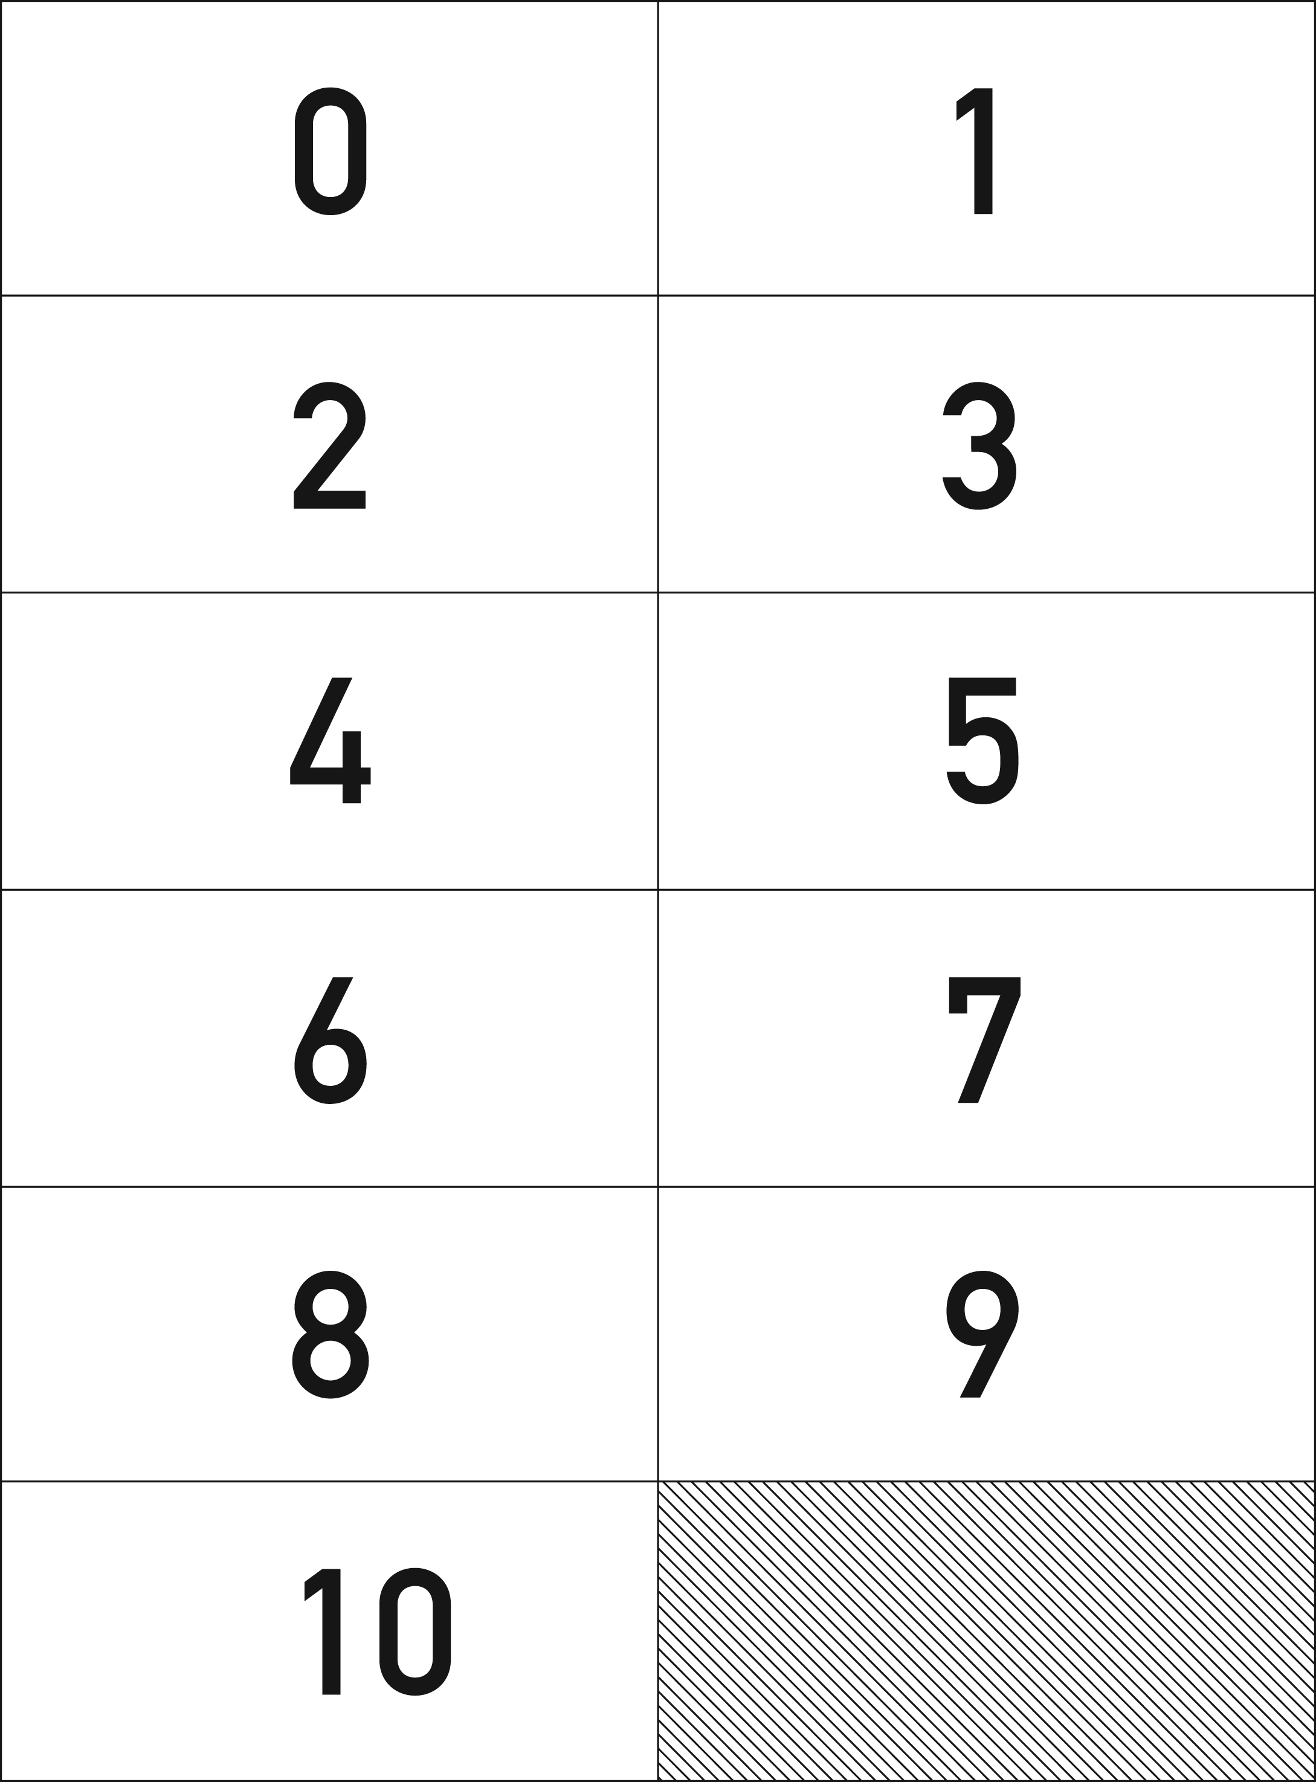
4

